Task 5: Power BI Dashboarding
Develop a comprehensive and interactive dashboard on PowerBI that integrates key metrics and insights derived from the "movies.csv" dataset. The dashboard should provide a holistic view of the movie industry trends, focusing on movie performance, genre popularity, director and star impact, and financial analysis of movie earnings.

Key Elements to Include:
- Movie Performance Overview:
  - Display key metrics like total number of movies, average IMDb score, and distribution of movies by rating. Include a breakdown of movies by decade.
- Genre Popularity Tracker:
  - Include metrics such as the number of movies per genre, average gross earnings by genre, and a ranking of genres based on popularity and financial success.
- Director and Star Analysis Panel:
  - Visualize key data points such as top directors and stars based on average gross earnings and IMDb scores. Include a feature to select a director or star to view their movie portfolio.
- Financial Analysis of Movies:
  - Create a financial summary showing total gross earnings, average budget, and profitability of movies. Include a comparison of budget versus gross earnings for top-performing movies.
- Interactive Features:
  - Implement slicers, dropdowns, and timeline controls to allow users to filter data across different dimensions (e.g., time periods, genres, directors, stars). Ensure functionality for dynamic interaction with the data.

PowerBI Dashboard Image :
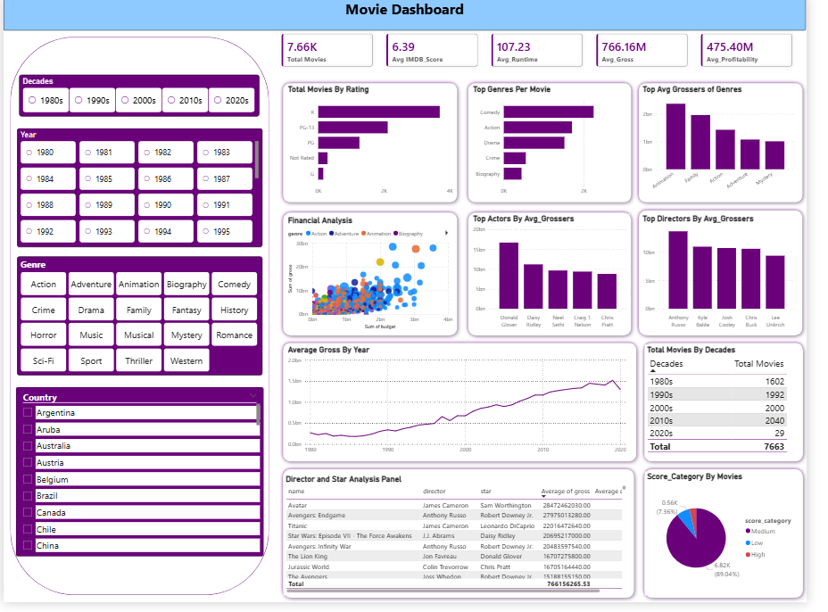

Task 6: GenAI + n8n Automation

Now imagine this real-world problem:
“Business teams and content managers don’t want to open dashboards every day.
They want automated insights and explanations.”
Your task is to build 2 automation workflows using n8n + GenAI.

Problem I: Automated Movie Performance Insight Generator
Automatically convert dashboard metrics into plain-English insights using GenAI.
n8n Workflow Logic
- Trigger
  - Daily or weekly (Cron node)
- Input Data
  - Exported dashboard KPIs / CSV:
    - Top 5 movies by gross
    - Budget vs Gross ratio
    - Highest rated movies
    - Worst performing high-budget movies
- GenAI Step
  - Send structured data to GenAI
  - Ask it to:
    - Summarize performance
    - Highlight success & failure patterns
- Output
  - Email message with AI-generated summary

N8n workflow image :
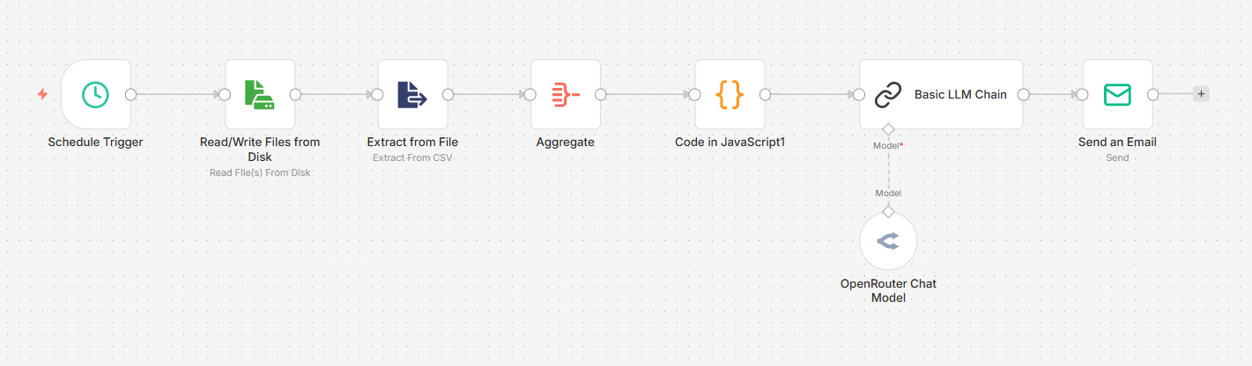

Project workflow Explanation :
1. Schedule Trigger
This just decides when the system should run automatically (daily/weekly), so you don’t have to do it manually.

2. Read File from Disk
It opens your saved dashboard data file (CSV), like opening an Excel sheet.

3. Extract from CSV
This converts raw file data into a structured format (rows & columns) so the system can understand it.

4. Aggregate
It summarizes the data (like top movies, averages, worst performers) instead of looking at raw rows.

5. Code (JavaScript)
This is where you apply logic — like calculating ROI or preparing clean data for analysis.

6. Basic LLM Chain
This step prepares the question and instructions for the AI (what to analyze and how to respond).

7. OpenRouter Chat Model (LLM)
This is the AI brain — it reads the data and converts it into simple English insights.

📧 8. Send Email
Finally, it sends the insights directly to your inbox, so you get ready-to-use analysis without opening any dashboard.

My Email Response :
Movie Insights Report
1. Summary:
The movie dataset consists of ten films with varying ratings, budgets, and gross revenues. The highest-grossing film is Avengers: Endgame with a gross of 27975013280, while the lowest-grossing film is Rock & Rule with a gross of 303790. The average rating is 6.3, and the average budget is 11333333333.5.

2. Insights:
- Avatar and The Shawshank Redemption are the only films with a rating above 9, and they are also among the top three films in terms of gross revenue.
- Films with higher budgets generally have higher gross revenues, but this is not always the case (e.g., Rock & Rule and Brenda Starr).
- The lowest-rated films, Superbabies: Baby Geniuses 2 and From Justin to Kelly, also have the lowest gross revenues.

3. Recommendations:
- To increase the chances of success, filmmakers should aim for a high rating and a large gross revenue. This can be achieved by focusing on storytelling, production quality, and marketing.
- Producers of low-budget films should aim for a high rating to maximize their return on investment.
- Filmmakers should be cautious when investing large budgets in films with low potential for high gross revenues. Instead, they should consider investing in films with a proven track record or a strong marketing strategy.

Problem II: AI Movie Recommendation & Explanation Automation
Build an AI-powered explanation system that answers why certain movies succeed or fail.
n8n Workflow Logic
- Input
  - User question via:
    - simple form
Examples:
    - “Why did Movie X perform poorly?”
    - “Which genres give best ROI?”
- Fetch Relevant Data
  - Movie details:
    - Budget
    - Gross
    - Genre
    - IMDb score
    - Votes
    - Runtime
- GenAI Reasoning
  - Ask GenAI to:
    - Explain performance
    - Compare with similar movies
    - Give data-backed reasoning
- Response
  - Return explanation as text

n8n workflow and Output :
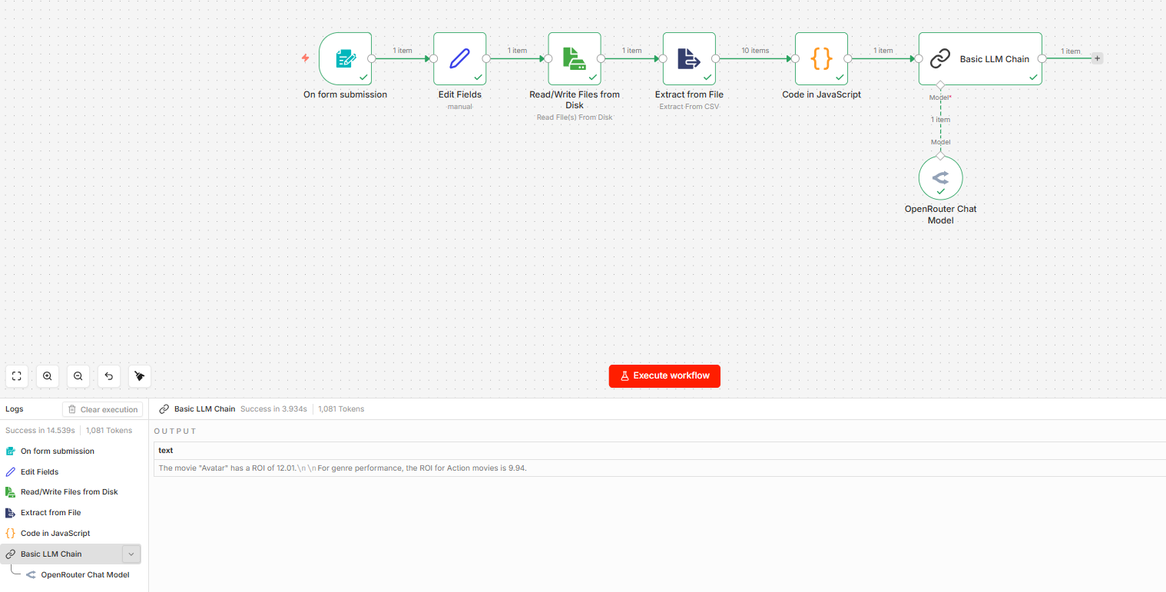

1. Form Submission
This is where the user asks a question (like “Why did this movie fail?”) — basically the starting point.

2. Edit Fields
It just cleans and organizes the question, so the system can use it properly.

3. Read File from Disk
This step opens your movie data file (CSV), like opening an Excel sheet.

4. Extract from CSV
It converts the file into structured data (rows & columns) so the system can understand it.

5. Code (JavaScript)
This is where you prepare the data and logic — like calculating ROI or picking relevant movie details.

6. Basic LLM Chain
Here you tell the AI what to do — like “explain why the movie performed this way using data”.

7. OpenRouter Chat Model (LLM)
This is the AI brain — it analyzes the data and gives a clear, human-like explanation.
User Input on form : Tell me about the Avatar Movie
Output : The Movie “Avatar”, has a ROI of 12.01. For the Genre Performance, The ROI of Action movie is 9.94

